CORRECCION EVALUACION PRECESUAL #1 - INGLES
- COMPLETE THE PARTS OF THE HOUSE:
1
6
5
4
3
2
7
8
D
C
B
A
____ _____ _____ _____ _____
___ ___ ___ __ ___ ___ __ ___
___ ___ ___ __ ___ ___ ___
___ ___ ___ __ ___ ___ ___
_ _ __ __ _ _ _ _ _ _
_ _ __ __ _ __ _ _ __ __
___ ___ ___ ___ ___ ___ ___ ___
__ __ __ __

 | 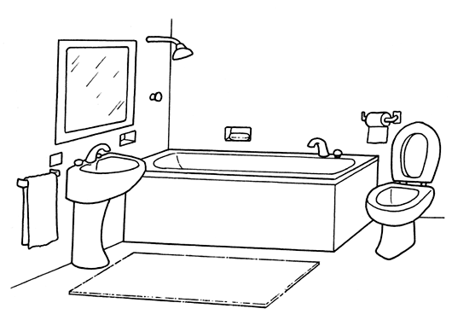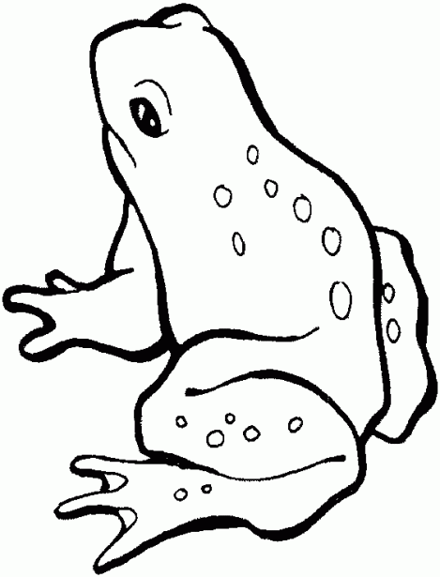 |  |  | 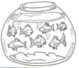  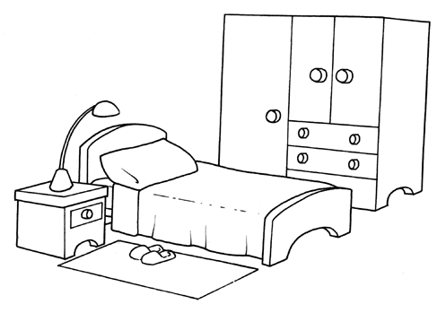
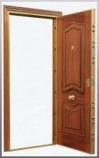
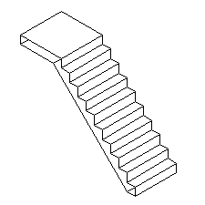
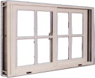

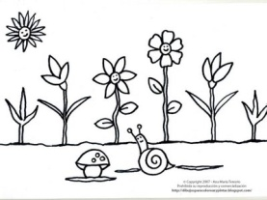  __ __ __ __ __ __ | 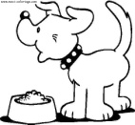  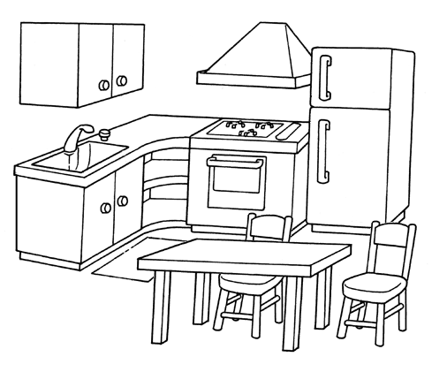 | 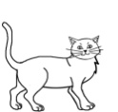  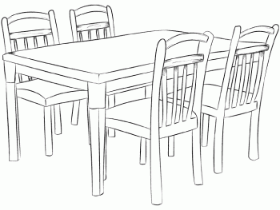 |  |  | 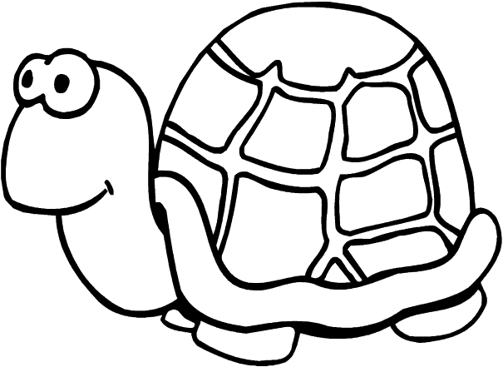  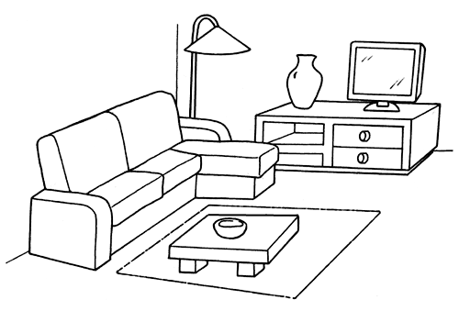 | 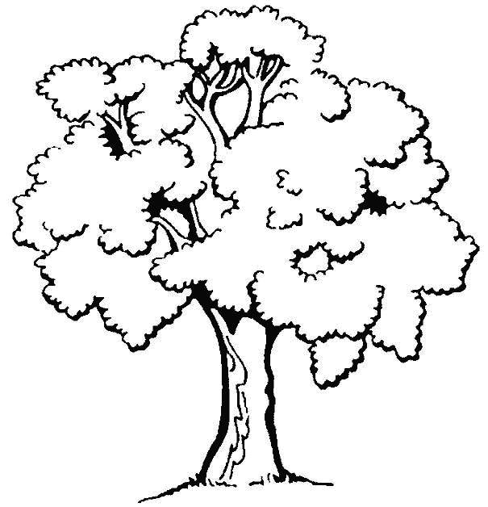  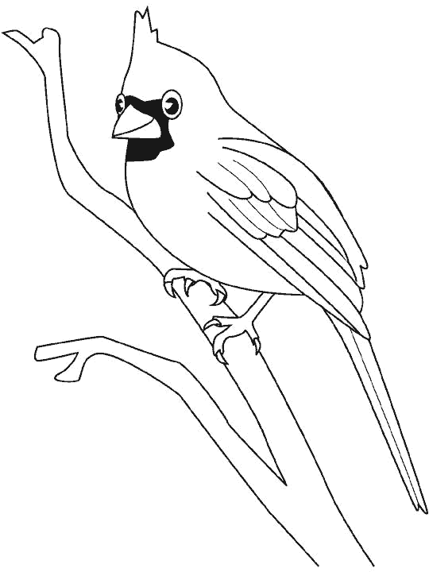  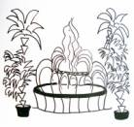
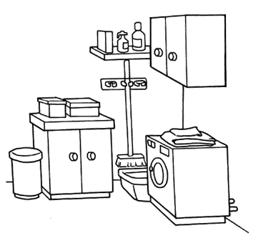
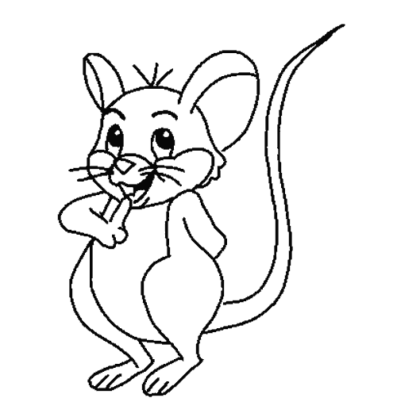

- ACCORDING TO THE PICTURE ASK AND ANSWER. (De acuerdo con la imagen preguntar y responder).
- (1) Donde está el caracol? R: El caracol está en el jardín.
- ______________________________________ A: The snail is in the garden.

- (2) ___________________________________ R:_____________________________________________
2. _______________________________________ A:_____________________________________________

3. (3)_______________________________________ R:_____________________________________________
3. ________________________________________ A:_____________________________________________

4. (4) _______________________________________ R:_____________________________________________
4. ________________________________________ A:_____________________________________________

5. (7)_______________________________________ R:_____________________________________________
5. ________________________________________ A:_____________________________________________
2. ANSWER:
A. What is letter A? _______________________________________________________
B. What is letter B? _______________________________________________________
c. What is letter C? _______________________________________________________
d. What is letter D? _______________________________________________________
3. WHO IS IT? – UNSCRAMBLE THE LETTERS AND DRAW.
LI CE PO M N A | SE RUN | LI POT | V IR D E R | TO R O D C
TI S NE D T | CHER TEA | TO RAC | Y O B | L IR G

4. MATCH. WEEKLY ICFES QUESTION.
1. she ______ drawing a picture. a. orange
2. you ______ sleeping on bed. b. T.V
3. I ______ playing basketball. c. is
4. Marian is watching some ________ d. Living room
5. Jose is eating a _______ e. are
6. My mother is in the_______ f. am
7. My favorite color is_________ g. hot dog
6. CHOOSE AND CIRCLE THE RIGHT ANSWER:
 | - Poor  - Rich  - slow |  | - sad  - fast  - big | 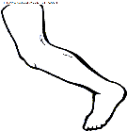 | - knee  - feet  - head | 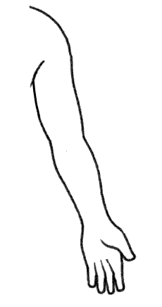 | - arm  - shoulder  - eye
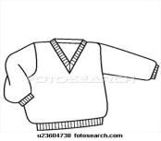 | - pants  - dress  - sweater | 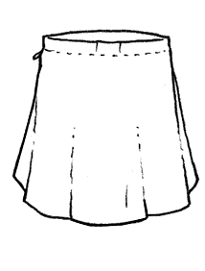 | - shirt  - skirt  - short |  | - ugly  - beautiful  - sad | 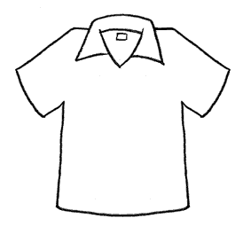 | - shirt  - t-shirt  - skirt

7. COMPLETE WITH a ---- an.
 | orange |  | duck |  | umbrella |  | student |  | elephant
 | chick |  | arm |  | donkey |  | alligator |  | dog

CORRECCION EVALUACION PRECESUAL #2 - INGLES
- ANSWER THE FOLLOWING QUESTIONS.
Where is the boy?  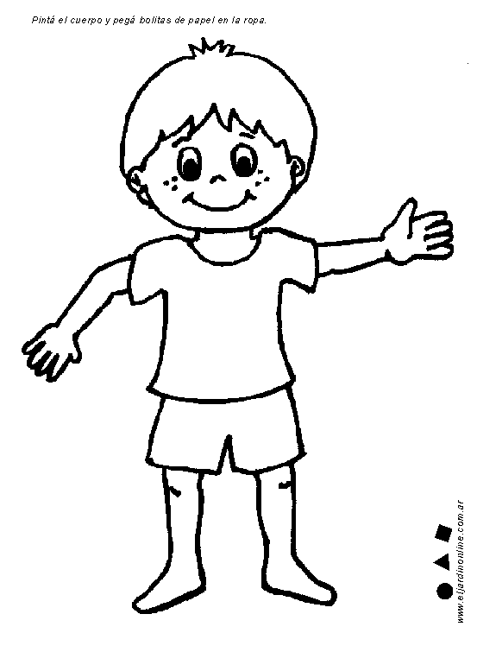 | Where is the ball?  
Where is the dog?  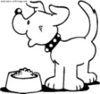 | Where is the cat?  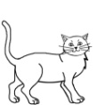
Where is the rabbit?  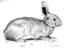  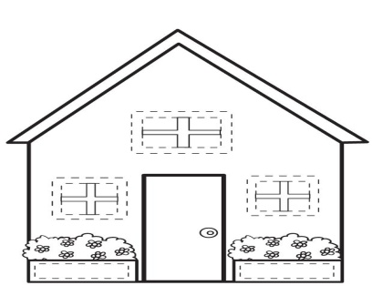 | Where is the girl?  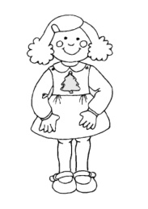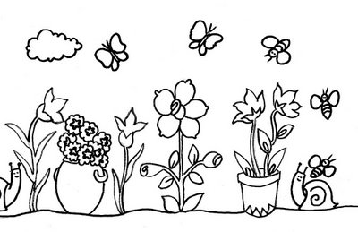

- WHAT IS IT?
What is this?  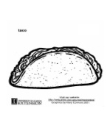 | What is it?  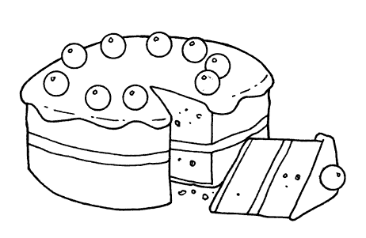 | What are these?  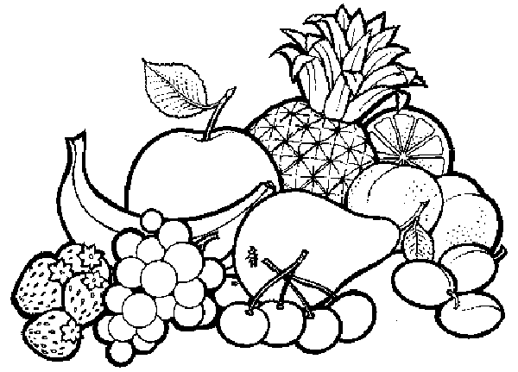
What is this?  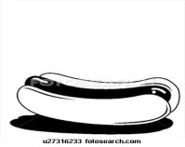 | What is it?  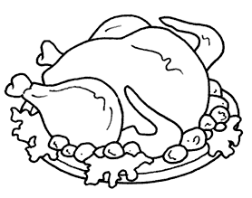 | What are these?  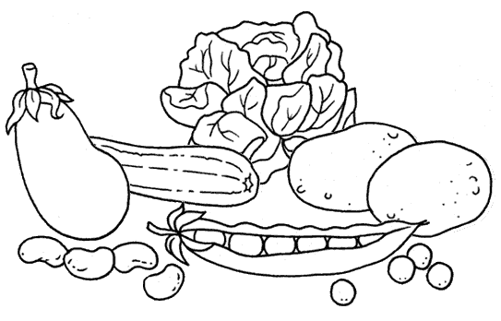
What is this?  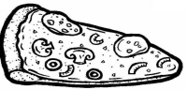 | What is it?   | What is this?  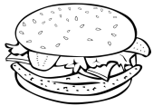

- ASK QUESTIONS.
- Is / What / doing / she/ ?_______________________________________________
- He / is / Where / ?____________________________________________________
- Are / Who / they ?____________________________________________________
- old / are / you / How ?__________________________________________________
- your / is / What / name?________________________________________________
- WRITE AND DRAW 10 EXAMPLES OF CLOTHES.
1. | 2. | 3. | 4. | 5.
6. | 7. | 8. | 9. | 10.

- MATCH. WEEKLY ICFES QUESTIONS.
- ( ) She is cooking dinner in the | - Garden
- ( ) You are sleeping in the | - Living room
- ( ) I am playing soccer in the | - Bathroom
- ( ) Marian is watching some T.V. in the | - Dining room
- ( ) Jose is eating a hot dog in the | - Kitchen
- ( ) The bathtub is in the | - Bedroom
- ( ) My mom is watering the flowers in the | - yard

- CHOOSE AND CIRCLE THE RIGHT ANSWER.
 | - Poor  - Rich  - slow |  | - sad  - fast  - big |  | - knee  - feet  - head |  | - arm  - shoulder  - eye
 | - sad  - thirsty  - happy | 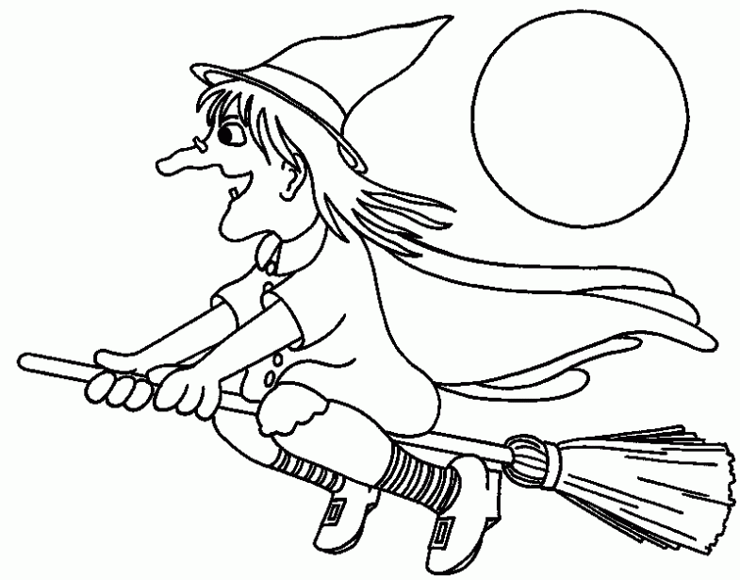 | - shirt  - witch  - sister | 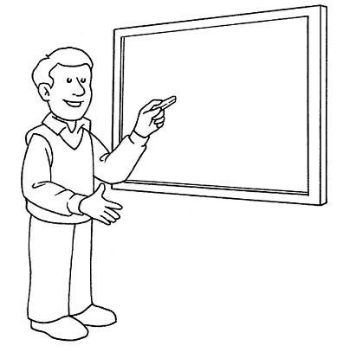 | - teacher  - doctor  - pirate | 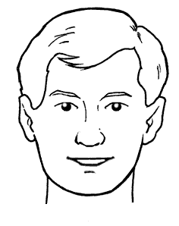 | - foot  - leg  - head

- COMPLETE WITH a ------ an.
 | apple |  | orange |  | teacher |  | student |  | elephant
 | chick |  | arm |  | driver |  | alligator |  | angel

- WRITE THE RIGHT ADJETIVE:
HOT - COLD- FAST - SLOW - HAPPY - SAD -TALL - SHORT - BIG – SMALL - RICH - POOR- BEAUTIFUL - UGLY
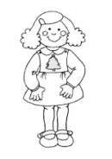 |  |  |  | 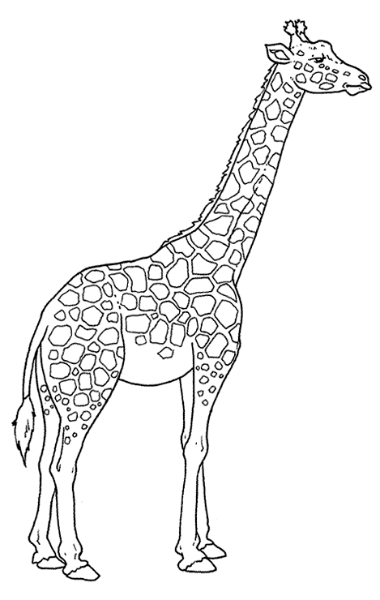 |  | 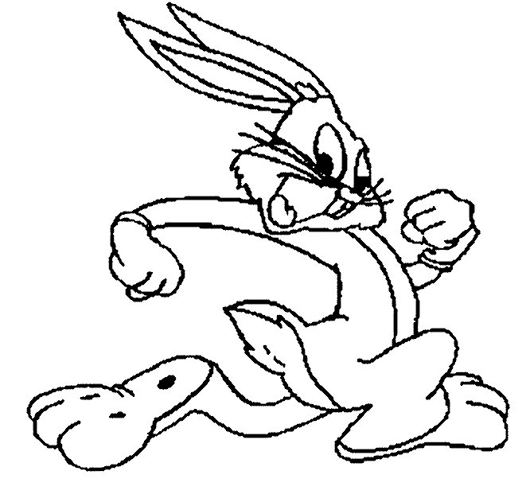
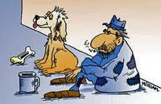 |  |  | 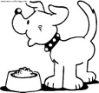 | 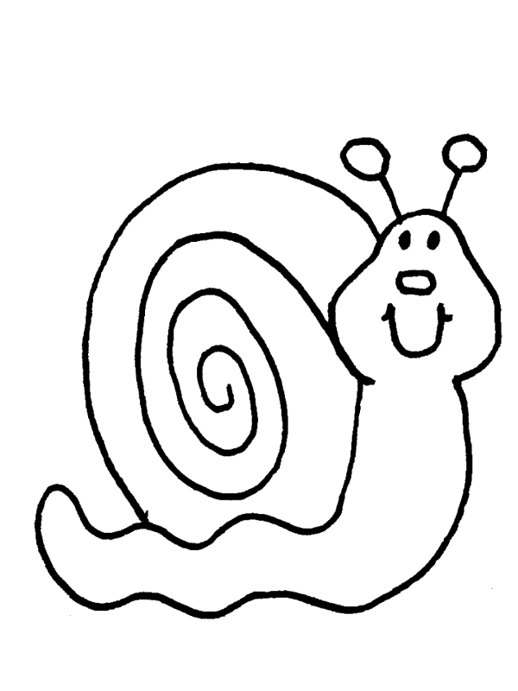 | 